Operating Systems – 2

Assignment 1 – Report

Sumanth Reddy Cherupally

EE17BTECH11041

**Design of the program**

1)Rate Monotonic scheduling -

I created a vector of structs containing all the parameters of a process. Then duplicate this vector so that othe first one can be used as reference, while the duplicate can be modified. Then both the vectors are sorted in the order of their periods and this order remains constant throught the program. Iterate over the vector in the sorted order to know whether the process is ready to be executed by incrementing the TIMER one by one.

2)Earliest Deadline First scheduling -

Two vectors were created as mentioned above but one for reference and the other one is sorted each time a new instance of the process becomes ready to be executed. Both these vectors are first sorted based on their period(deadline) then the deadline is dynamically updated in the duplicate vector and sorted again each time a new process enters. This also checks by incrementing the TIMER one by one.

The difficulties I faced were during

**Comparison**

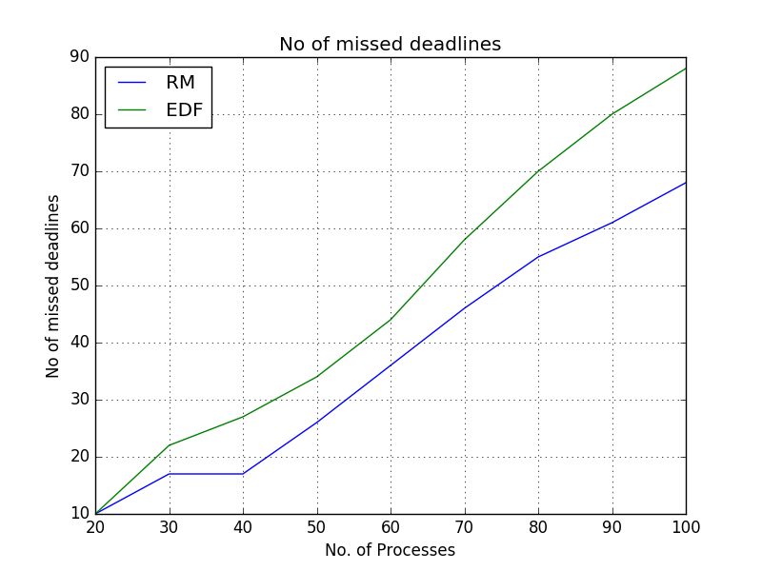

As we can see the number of processes nmissing deadlines are higher in EDF than in RM.

The following is the graph for total average waiting time

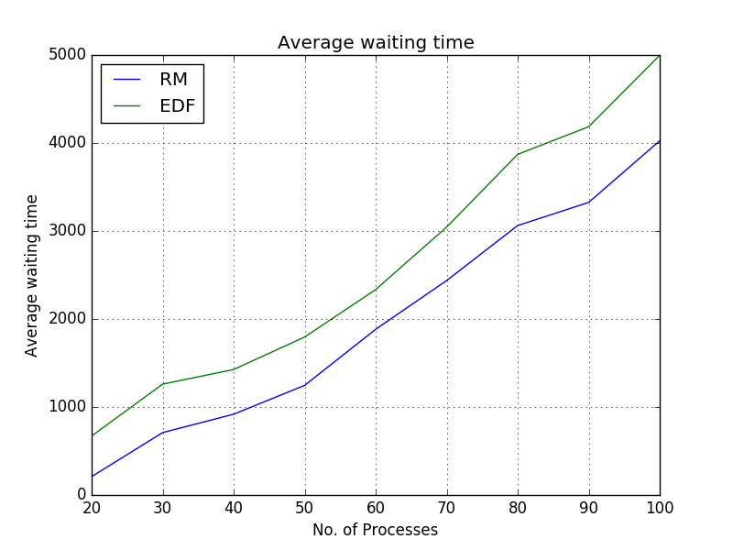

The average waiting time of EDF is higher than of RM for the same set of processes.